**Shell Scripting and Operations​**

Shell is an interface of the operating system. It accepts commands from users and interprets them to the operating system.

## Creating a Shell Script

Login to your Linux machine and open the terminal, navigate to the folder where you want to store the shell script. Shell scripts end with the extension “.sh”. Let’s create our first shell script. Type in

touch script.sh

Now, this script file is not executable by default, we have to give the executable permission to this file. Type in

chmod +x script.sh

Now, we will add some commands to this shell script. Open this shell script with any text editor of your choice (command-line based or GUI based) and add some commands. We will use nano. Type in

nano script.sh

Add the following commands to test this shell script

echo This is my first shell script

touch testfile

ls

echo End of my shell script

Save the changes, and run the shell script by typing in

./script.sh

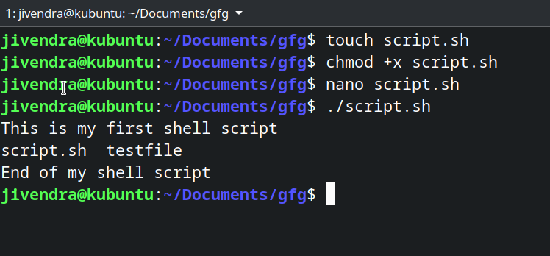

You can see, it executed all the specified commands.

## Comments in the shell script

Any line which starts with “#” in the shell script is treated as a comment and is ignored by the shell during execution, except the shebang line, which we will see later in this article. Let’s see an example. A shell script is created with the following content.

# This is a comment

echo Testing comments in shell script

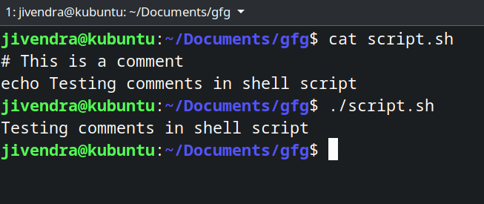

You can see, the comment gets ignored.

## Variables in Shell Script

Yes, Shell scripts support the use of variables, and we need not define a variable’s type during its declaration. There are two types of variables:

* System Defined variables
* User-Defined Variables.

System-defined variables, also called environment variables, are generally Capitalised. You can view all the current environment variables using the printenv command. User-Defined variables are set by the user, and they exist only during script execution. You can define a variable by simply typing its name and assigning a value with = sign and access a variable by adding a $ before the variable name. Variables are demonstrated in the following example script.

# Accessing an Environment Variable

echo $USER

# Creating and accessing User defined Variable

variable_name="Edunet"

echo $variable_name

## Comparison Operators

You can compare two variables in shell scripting. We do these comparisons to make decisions, we will see how to do that later in this article, but before that, here is a list of some comparison operators.

### Integer comparison

| **Operator** | **Description** |
| --- | --- |
| -eq | is equal to |
| -ne | is not equal to |
| -gt | is greater than |
| -ge | is greater than or equal to |
| -lt | is less than |
| -le | is less than or equal to |

### String Comparison

| **Operator** | **Description** |
| --- | --- |
| == | is equal to |
| != | is not equal to |
| \< | is less than, in ASCII alphabetical order |
| \> | is greater than, in ASCII alphabetical order |

We add a \ before < and > because they need to be escaped when typed in the [ ] construct. Now, let’s see where these are used.

## Conditional statements

Conditional statements are used to execute a block of code only when certain conditions are met. Shell scripts support the use of conditional statements. We use comparison operators to check the conditions. Let’s see a few conditional statements.

### If statement

It checks the condition, and if it is conditioned true, it executes the commands.

**Syntax**

if [ condition ]

then

#statements

fi

Let’s see an example.

#!/bin/sh

x=10

y=11

if [ $x -ne $y ]

then

echo "Not equal"

fi

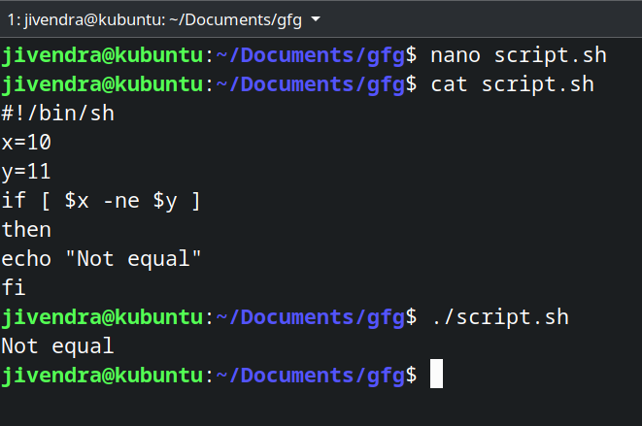

*.if statement*

### If-else statement

In an if-else statement, you can specify a set of commands to run if the condition is not met.

**Syntax**

if [ condition ]

then

#set of statements if the condition is true

else

#set of statements if the condition is false

fi

Let’s see an example

#!/Syntaxbin/sh

x=10

y=10

if [ $x -ne $y ]

then

echo "Not equal"

else

echo "They are equal"

fi

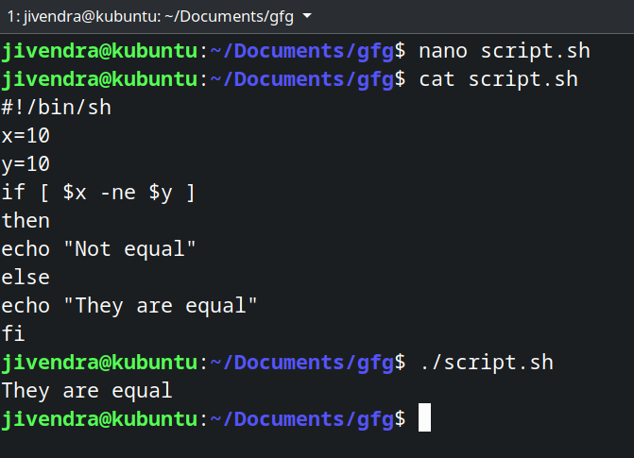

*.if-else statement*

There are other conditional statements, you can read about them [here](https://www.geeksforgeeks.org/conditional-statements-shell-script/).

**Note:**Type a space after [ and before ] while specifying the condition to be checked otherwise you will get an error.

## Loops

Using loops, you can a set of commands over and over again, until a certain condition is met. Let’s see some of the loops.

### While loop

It starts running the specified commands if the condition is true and repeats them until the condition is false.

**Syntax**

while [ condition ]

do

#set of statements

done

Let’s see an example.

#!/bin/sh

x=2

while [ $x -lt 6 ]

do

echo $x

x=`expr $x + 1`

done

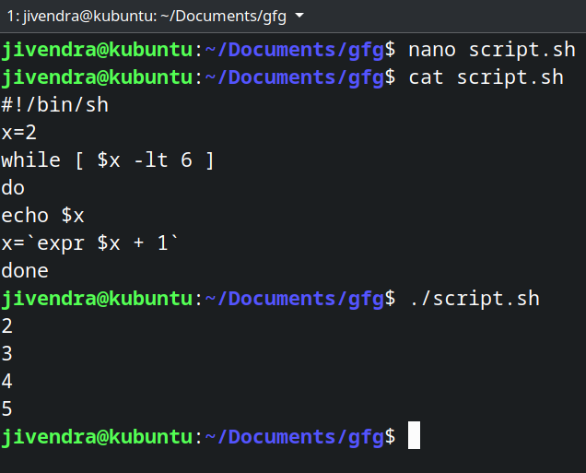

*While loop*

We enclose an expr statement within ` ` when assigning it to a variable.

### For loop

In a for loop, the variable iterates over a list of values and ends when there are no more values to iterate over.

**Syntax**

for var in val1 val2 val3

do

#statements

done

Let’s see an example.

#!/bin/sh

for var in 2 4 5 8

do

echo $var

done

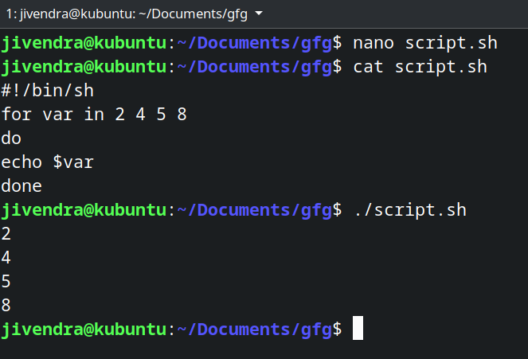

*for loop*

## Positional Arguments

Positional arguments are the arguments or values which we pass to the shell script while executing the script. They are accessed by variables $0, $1, $2 … $9. Beyond that, they are referenced by ${10}, ${11} and so on. $# stores the no of passed arguments and $0 stores the name of the script. Let’s see an example to understand all this.

#!/bin/sh

echo "No of arguments is $#"

echo "Name of the script is $0"

echo "First argument is $1"

echo "Second argument is $2"

To pass the arguments, just type them in the terminal after the script name as shown below.

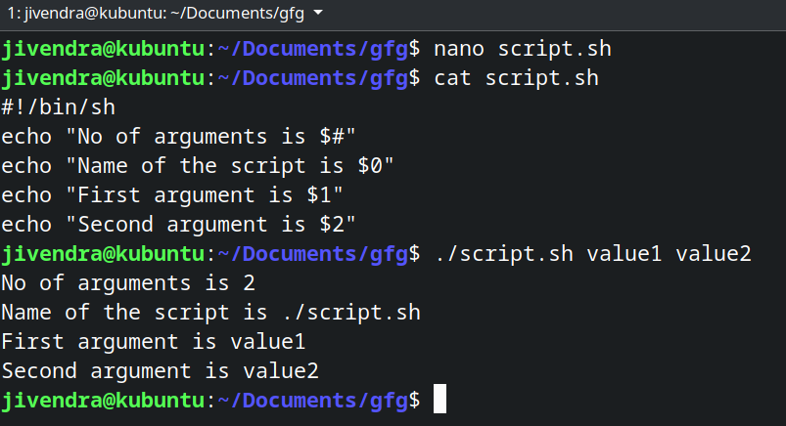

*Positional Arguments*

## Storing the output of commands

You can store the output of commands inside a variable in a shell script. There are two ways to do so.

**Syntax**

#Syntax 1

var=$(a valid linux command)

#Syntax 2

var2=`a valid linux command`

Let’s see an example.

#!/bin/sh

b=$(pwd)

c=`pwd`

echo $b

echo $c

d=$(ls /bin | grep bash)

echo $d

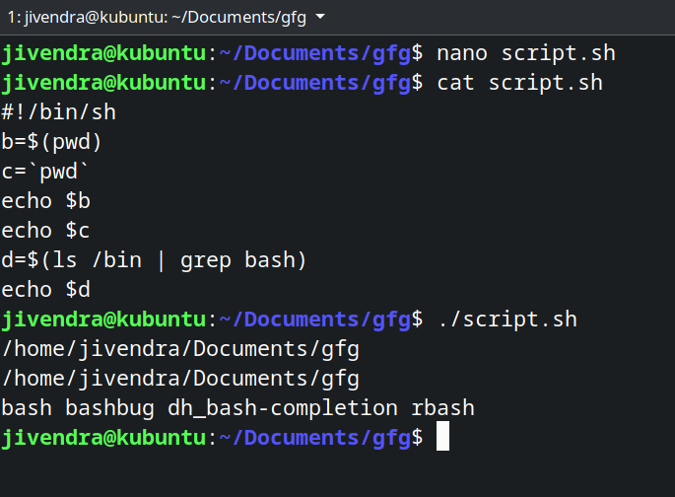

*Storing the output of commands*